Budget Rent-a-Car
of British Columbia

Fleet Control and Fleet Accounting Tutorial

Version 1.00

Note: The information contained in this document is confidential and may not be disclosed to any parties outside of Budget Rent-a-Car of British Columbia Ltd. without written consent by one of its officers.
Copyright (C) 2009 Budget Rent-a-Car of British Columbia Ltd.

Table of Contents

1 Overview of the Fleet Control Process 1
1.1 Receiving 2
Add a Vehicle 2
Transfer Ownership of Vehicle 3
Record a Vehicle Purchase 4
1.2 Placement 5
Change Vehicle Status 5
1.3 Rental/ Lease Use 9
Check out Vehicle 9
Lease Vehicle 11
1.4 Disposal 12
Turn Back Vehicle 12
Change Order of Vehicle 12
Write Off Vehicle 12
Sell Vehicle 12
2 Maintenance Modules 13
3 Fleet Master 16
3.1 Purchase 16
3.2 Depreciation 18
2.3 Loan 20
3.4 Lease 23
3.5 Estimation & Sales 24
4 Month End Processing 26
Loan Amortization 26
Vehicle Amortization 28
Lease Amortization 30
5 Export data to ACCPAC 31
6 Reports 35
6.1 Fleet Operation Reports 35
New Vehicle Reports 35
Turn Back Lease Reports 35
Foreign Vehicle Control 35
Missing Kilometers 35
Fleet Turn Back Schedule Summary – Daily 35
Fleet Turn Back Schedule Summary – Monthly 35
Vehicle Utilization – Current 36
Units Available for Rent 36
Fleet Mix 36
6.2 Fleet Accounting Reports 38
Monthly Amortization Report 38
Loan Amortization Report 38
Lease Amortization Report 38
Key Tag Report 38
Car Sales Summary Report (for Buyer) 38
Car Sales Summary Report (for Seller) 38
Vehicle Purchase Agreement 38
Vehicle Release Form 39
Loan Payout Report 39
BMO Loan Payout Report (for Bank) 39
Car Sales Analysis 39
Car Sales Estimation 39
Volume Incentive Report 39

1 Overview of the Fleet Control Process

There are six major phases in the fleet life cycle at Budget. We will use GIS in Phases 3 to 6.

- Planning – plan what vehicles to buy when to buy them and how to finance them.
- Ordering – place orders for vehicles with the manufacturers
- Receiving – take delivery of vehicles, place them into Budget’s fleet inventory and pay for them
- Placement – allocate vehicles for appropriate uses such as rental or lease.
- Rental/ Lease Use – track location and status of vehicles during their lifetime at Budget
- Disposal – remove vehicles from the fleet inventory to be sold or returned to the manufacturer.

1.1 Receiving

Add a Vehicle
Vehicles purchased by Budget become part of the latter’s fleet inventory as soon as they are delivered to a Budget location. In GIS, you can access the Add to Inventory screen from the Fleet Control/Inventory menu. Here, enter all information pertaining to the new vehicle (See Figure 1). Click on Save to complete the vehicle addition process. You will see that GIS has assigned your new vehicle a unit number (The unit number assigned in this tutorial is #167799. Remember this since we will be using it a lot.) and has set its status to ‘Drop Ship’. We will talk more about a vehicle’s status later.

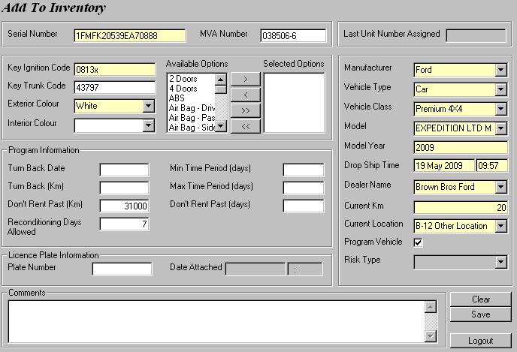
Figure 1: Adding a vehicle to your fleet inventory via the Add To Inventory screen.

TIP!
GIS allows for a rapid entry of multiple vehicles since it retains all non-unique fields on this screen. All you need to do is enter the unique fields, such as the serial number and poof, a new vehicle is added within seconds!

NOTE
There are many ways to attach a licence plate to a vehicle in GIS depending on when you need the vehicle. For example, if you need to rent a car out as soon as you receive it, assign a plate number to it here in the Add To Inventory screen.

Usually, a licence plate is attached to your newly added vehicle through the Fleet Master screen, which we will cover later in the chapter.

Transfer Ownership of Vehicle
To do this, assign a licence plate to your new vehicle. On the Fleet Control menu, select Licencing, then select Licence Inventory. Retrieve an existing licence plate number and associate the unit number of your new vehicle with it. Click on Save (See Figure 2) and now the vehicle officially belongs to Budget! GIS will change the status of the vehicle to ‘Owned’.

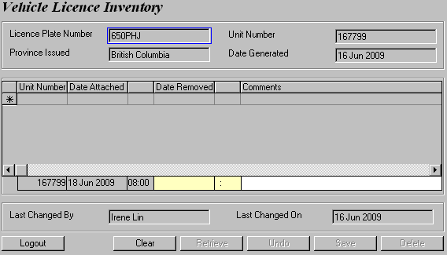
Figure 2: The Vehicle Licence Inventory screen.

The step above assumes that we already have a licence plate number. All licence plate numbers are stored in the Vehicle Licence Inventory screen. What if we don’t? Let’s assume that we did not have the licence plate 650PHJ available in the first plate, so we need to generate it in the GIS database.

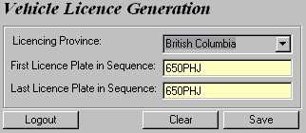
First, select Licence Generation from the Fleet Control/Licencing menu. Then enter the licence plate number following the format of ABC123 or 123ABC, which in our case is 650PHJ (See Figure 3). Click Save and the licence is successfully generated.
Figure 3: Generating a licence plate number.

Record a Vehicle Purchase
This typically takes place two weeks after the vehicle’s ownership is transferred. Open the Fleet Master screen from the Fleet Control/Accounting menu. Enter the Unit Number (#167799, remember?) of your new vehicle and click Retrieve. Then, go to the Accounting/Purchase tab and start recording the purchase details of your new vehicle, as shown in Figure 4. Save your work after that.

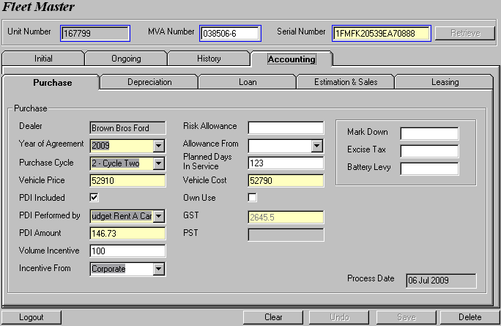
Figure 4: Entering the purchase information of your new vehicle in GIS’ purchase screen.

1.2 Placement

Change Vehicle Status
The vehicle status indicates what stage a vehicle is at in its life cycle in terms of ownership and usage (See Figure 5).

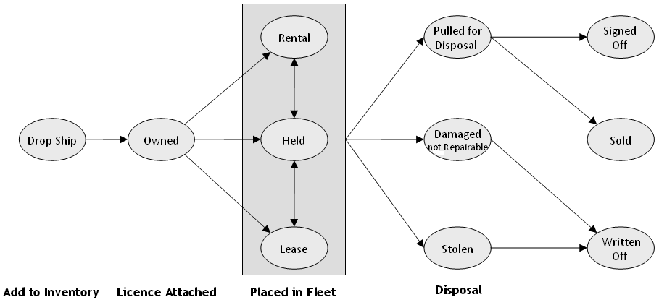
Figure 5: The vehicle status life cycle.

Once a vehicle is owned by Budget, it can be allocated for use as a lease or a rental vehicle. Before you start leasing or renting out the vehicle, you must change its status first. To do this, expand the Fleet Control menu, select Use and click Status Update. Retrieve your vehicle by entering its unit number – #167799. Notice that the status of the vehicle is ‘Owned’ since you already assigned a licence plate number to your vehicle. Now, go ahead and change its status to ‘Rental’ (See Figure 6). Save your changes.

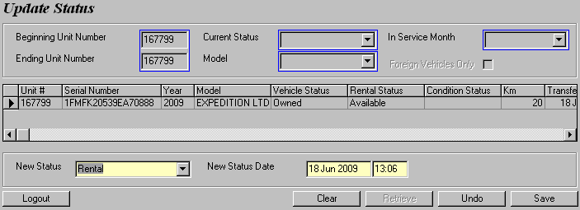
Figure 6: Changing the vehicle status to ‘Rental’ to start renting the vehicle.
NOTE
If you added a vehicle but cannot retrieve it in Update Status screen, don’t panic. You probably forgot to attach a licence plate number to your vehicle.

Retrieve your vehicle in the Fleet Master screen and go to the Ongoing sub screen. In the Licence Information section, enter the Licence Plate Number, Attached on Date and Licence Province/State, as shown in Figure 7. Switch to the Initial tab to enter the Ownership Date and time (i.e. The time you attach a licence plate). Once you save your changes, your vehicle will now be retrieved successfully in the Update Status screen.

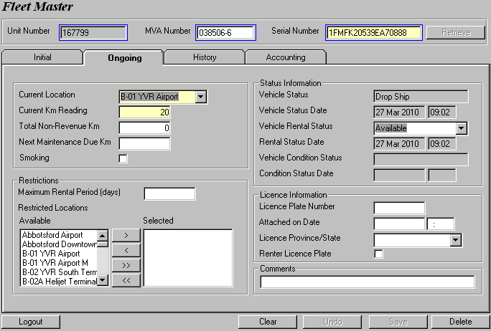
Figure 7: The second way to attach a licence plate is through the Fleet Master screen.

Once you change the vehicle status to ‘Rental’, notice that GIS also sets the vehicle’s Condition Status to OK.

Since we are already in the Update Status screen, let’s take some time to get you familiarized with all the available vehicle statuses in GIS.

- Drop Ship – The vehicle has been delivered to a Budget location, either directly from the manufacturer or via a dealer.

- Owned – The vehicle has a licence plate attached.

- Rental – The vehicle is being used as a rental vehicle. Depreciation starts at this point.

- Held – The vehicle is being held without being used in order to maximize its resale value.

- Lease – The vehicle is being used as a lease vehicle. Depreciation starts at this point.

- Pulled for Disposal – The vehicle has been pulled from rental or lease use and returned to the main Budget location for turn back or pre-sale servicing. Third-party insurance coverage stops at this point.

- Damaged: Not Repairable – The vehicle has been in an accident and cannot be repaired. Third-party insurance coverage stops this point.

- Stolen – The vehicle has been stolen for more than six months. Third-party insurance coverage stops at this point.

- Signed Off – The vehicle has been returned to the manufacturer under a turn back agreement. Depreciation stops at this point less the number of days allowed for turn back servicing.

- Sold – The vehicle has been sold. Depreciation stops at this point.

- Written Off – The vehicle has been written off (destroyed in an accident or stolen and not recovered). Depreciation stops at this point.

You should also get to know the different vehicle condition statuses on GIS. The vehicle condition status indicates what physical condition a vehicle is currently in. Condition statuses are normally set in the contract, maintenance and claims modules.

- OK - The vehicle can be rented or leased.

- Damaged: Not Drivable – The vehicle is damaged and cannot be safely driven.

- Damaged: Not Rentable – The vehicle is damaged and cannot be rented again until it is repaired.

- Damaged: Rentable – The vehicle is damaged, but can be rented if necessary.

- O/S: Not Rentable – The vehicle is out of service due to mechanical problems and cannot be rented again.

- O/S: Rentable – The vehicle is out of service due to mechanical problems, but can be rented if necessary.

- Maintenance: Not Rentable – The vehicle needs maintenance and cannot be rented again until it has been done.

- Maintenance: Rentable – The vehicle needs maintenance, but can be rented if necessary.

- Stolen - The vehicle is missing or stolen and cannot be rented again.
Lastly, we will talk about the three vehicle rental statuses that indicate what stage a vehicle is currently at in its rental usage.

- Available – The vehicle is available for rental. The rental status will be set to Available when the vehicle is first allocated for rental and every time it is checked in on a contract.

- On Rent – The vehicle is currently being rented and cannot be rented again until is returned. The rental status will be set to On Rent every time the vehicle is checked out on a contract.

- In Transit – The vehicle is currently being moved.

1.3 Rental/ Lease Use

Once a vehicle is allocated for rental use it can be moved between locations, rented on contracts and returned from rental. We can handle the rental and return of vehicles on contracts through the Contract menu.

Check out Vehicle
Once the status of your vehicle is set to ‘Rental’, you are free to rent your vehicle to the public now. To do that, select Contract Open/Check Out from the Contract menu and fill in the rental schedule, your customer’s details (name, licence #, data of birth, contact information) and your vehicle’s information (unit #, licence, KM reading), as shown in Figure 8.

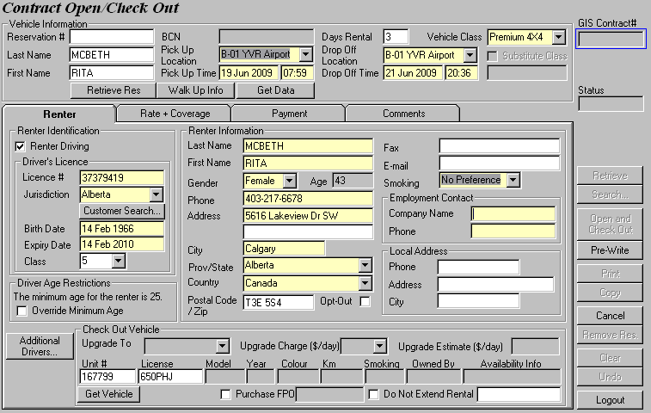
Figure 8: Opening a contract.

After you apply the rental rates and receive payment from your renter, proceed to check out the vehicle. Your vehicle’s rental status will then be set to ‘On Rent’. This check out date is the first official rental date of your vehicle and is known to GIS as the vehicle’s in-service date (ISD). GIS ISD will come in handy in the future, so remember this term.

NOTE
If you only change the status of your vehicle to ‘Rental’ in the Status Update screen without actually renting out the vehicle, GIS ISD will remain empty. If you change the status of your vehicle to ‘Lease’ after the status ‘Owned’, then GIS ISD defaults to the date you make that change.

When the vehicle is returned, you can check in your vehicle via Contract Check In from the Contract menu. GIS will change your vehicle’s rental status to ‘Available’.

NOTE
You can check the vehicle’s rental status in Fleet Master’s Ongoing screen or via Status Update.

We can keep track of the vehicle’s movement history in Fleet Master’s History screen. This screen also records all the changes in the vehicle’s status and condition status. Recall that the status of the vehicle is set to ‘Drop Ship’ when you add it to the vehicle inventory and is changed to ‘Owned’ after you assign it a plate number. These changes are all recorded in the Vehicle Status History section. You may also recall that the vehicle’s condition status is set to OK when the vehicle is first allocated for rental. Any changes made to the vehicle’s condition status will be recorded in the Vehicle Condition Status History section (See Figure 9).

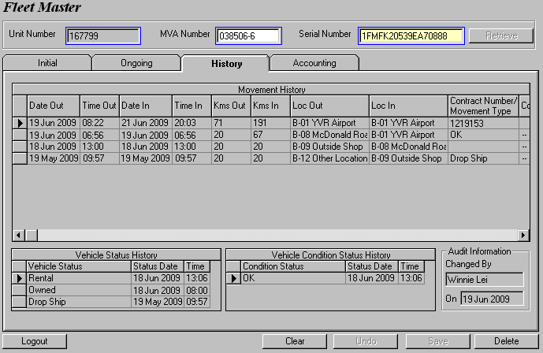
Figure 9: GIS stores the entire movement history of each vehicle.

The contract that you opened and closed (i.e. checked in vehicle) is recorded on the very top of Movement History. You may notice that there are two records in between our initial drop ship entry and our vehicle check out entry. The vehicle was actually transferred to a different location from the place it was originally added to. Whenever the vehicle is moved, regardless of the reason, its movement must be recorded through the Vehicle Movement screen. You can access this screen by selecting Use from the Fleet Control menu.

Lease Vehicle
To lease a vehicle, change the vehicle’s status to ‘Lease’ and fill in the lease details in Fleet Master’s Lease screen. We will explain the latter in Section 3.4 Lease.

If you are leasing your newly added vehicle to a customer who is required to use his/her licence plate on the vehicle according to the lease agreement, you must not generate a licence plate for that vehicle! Instead, retrieve the vehicle in Fleet Master and enter the lessee’s licence plate information and Attached on Date in the Licence Information section. Check the Renter Licence Plate box to indicate that our vehicle is attached to our lessee’s licence plate and add a comment about the lessee in the Comments field below (See Figure 10). Remember to enter the Ownership Date and time on the Initial sub screen before clicking Save.

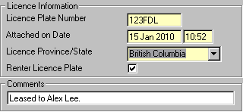

Figure 10: Attach the lessee’s licence plate to our vehicle by selecting the Renter Licence Plate checkbox.

1.4 Disposal

Turn Back Vehicle
Program vehicles are kept for normally 4 to 10 months. The period of time that the vehicles can be kept for and the maximum percentage of vehicles that can be kept by Budget at the end of that period are both defined in the purchase agreement with the manufacturer. Then, these Program vehicles are turned back to the manufacturer. When a vehicle is due for turn back, it is pulled from rental or lease use and returned to Budget’s main location.

If a Program vehicle is returned, go to the Vehicle Licence Inventory screen to remove its licence plate before changing its status to ‘Signed Off’ through the Update Status screen. This procedure will be explained in detail in Section 3.5 Estimation & Sales. If a Risk vehicle is returned, you must first ensure that its licence plate is physically removed. Next, go to the Update Status screen, select ‘Pulled for Disposal’ from the New Status drop down and check the Remove Licence box (See Figure 11). Now, turn back the vehicle using Fleet Master’s Estimation & Sales screen.

Figure 11: The Remove Licence checkbox removes the licence plate directly from the vehicle without having to go through the Vehicle Licence Inventory screen.

Change Order of Vehicle
At the end of the program term, Budget will keep some of the Program vehicles as Risk vehicles instead of turning them back to the manufacturer. Go to Fleet Master and uncheck the Program Vehicle option box under the Initial tab. Then select Risk Budget from the Risk Type drop down list.

Write Off Vehicle
Some vehicles are written off after being stolen or damaged in accidents. We can still sell a damaged vehicle but its selling price will no longer depend on the vehicle’s book value. The Fleet Accounting department will first need to obtain the selling price from the Claims department before updating the Sales section in Fleet Master. Most damaged vehicles are sold to ICBC.

If the vehicle is heavily damaged, you must change its vehicle status before you dispose of it or sell it. Ensure that its licence plate is physically removed before changing its status to ‘‘Damaged: Not Repairable’ and checking the Remove Licence box in the Update Status screen.

Sell Vehicle
Risk cars are normally kept for 1 ½ to 2 years (3 to 5 years for Risk trucks) and are sold after that. We also sell some Program cars instead of turning them back to the manufacturer. We will explain more about the sales procedures in Section 3.5 Estimation & Sales.

2 Maintenance Modules

We have a collection of fleet accounting maintenance modules that allows us to create and maintain data for Budget’s fleet. They are essentially databases (back-end) which allows you to control the data you want to display for selection in GIS (front-end) in each fleet accounting screen.

For example, entering a list of financial institutions in the financial institution module called FA_Financial_Institution will populate the Financial Institution drop down list in GIS’ fleet accounting’s loan screen (See Figure 12). Notice that each financial institution in FA_Financial_Institution has two values associated with it. If you make a selection in the Financial Institution field on GIS, the Tax Included and Setup Fee fields are automatically populated.

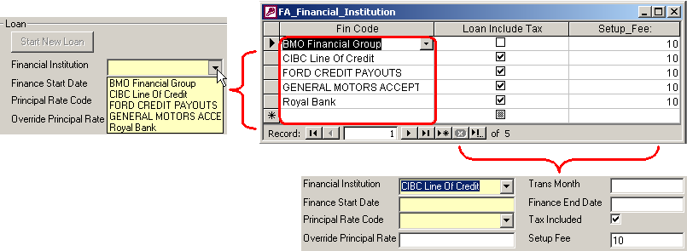
Figure 12: (Left) The list of financial institutions in GIS originates from the Fin Code column of the financial institution module. (Bottom) The Tax Included and Setup Fee fields retrieve their values from the remaining two columns of the financial institution module.

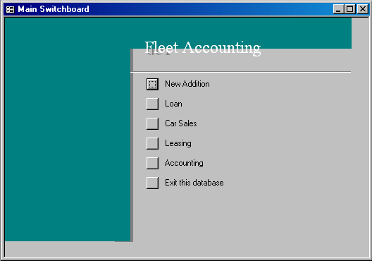
All modules are compiled into the fleet accounting maintenance tool, which can be accessed from C:\Program Files\GIS\FleetAccounting.adp. The first window you will see is the main menu, as shown in Figure 13.

Figure 13: The main menu of GIS’ fleet accounting maintenance tool.
Budget’s vehicles are acquired from the vehicle manufactures through direct purchase (Risk Vehicles) or via turn back agreements (Program Vehicles) under the terms of purchase agreements. These purchase agreements contain information such as the vehicle’s model, year of agreement, purchase cycle, purchase price, depreciation amount/rate, incentive, rebate, planned days in service etc.

You might remember some of these terms from Fleet Master’s Purchase screen. And you’ve probably figured out that you have to record the purchase information from the purchase agreement in GIS for every vehicle you add. Every time you add a vehicle, you need to look up the purchase agreement to get all the necessary purchase data. What if you have a lot of new vehicles with the same purchase agreement? Re-entering the same data sounds like a lot of work, doesn’t it?

Worry not! The fleet accounting maintenance tool is here to your rescue! Its purchase agreement module allows you to record all the information on your purchase agreement for each vehicle model year. First, click New Addition on the main menu of the fleet accounting maintenance tool. Next, select Purchase Agreement to bring up a form called FA_Purchase_Agreement. You can view flip through the existing records with the and buttons located at the bottom of the form. To enter data in a blank form, click the button to jump to the last of the records and populate the fields accordingly with reference to the purchase agreement for your vehicle model EXPEDITION LTD MAX-2009 (a Ford Premium 4X4 car) in the form, as shown in Figure 14.

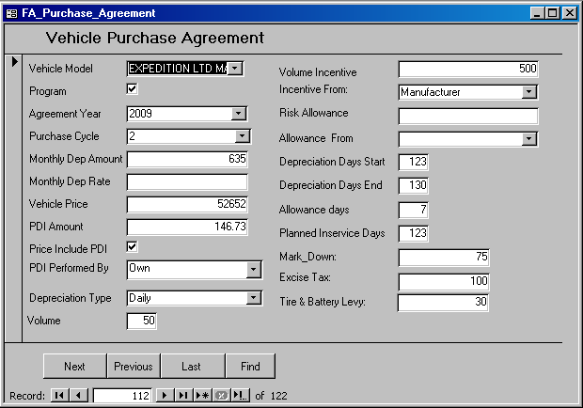
Figure 14: The first maintenance module – FA_Purchase_Agreement allows you to enter all vehicle information on the purchase agreement.

NOTE
In the main menu of the fleet accounting maintenance tool, you may notice that there are two choices for each module, one is named after the module name (form) and another with a “DS” (datasheet) extension. These two choices actually refer to the same module. The only difference is how the records in the module are being presented. See Figure 15 to learn how “Financial Institution” is different from “Financial Institution DS” even though both point to FA_Financial_Institution.

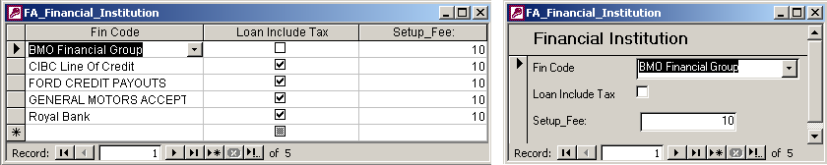
Figure 15: (Left) Datasheet view of FA_Financial Institution. (Right) Form view of FA_Financial Institution.

Fleet Accounting makes life easy by linking all the data you stored in the maintenance modules with GIS. In other words, any data you saved in the maintenance modules can be retrieved in GIS easily.

Let’s say you added three Program Cars of the model EXPEDITION LTD MAX-2009 into GIS. When you enter the purchase details in Fleet Master’s Purchase screen, you need only select the Year of Agreement (i.e. 2009) and Purchase Cycle (i.e. 2). After that, the Vehicle Price, PDI Included, PDI Performed by, PDI Amount, Volume Incentive, Incentive From, Risk Allowance, Allowance From, Planned Days In Service, Mark Down, Excise Tax and Tire & Battery Levy fields will be populated automatically based on your recorded data in the FA_Purchase_Agreement form for the EXPEDITION LTD MAX-2009 model. Imagine how redundant and time-consuming it would be when you perform the same data entry three times! Pre-setting the purchase agreement information in the fleet accounting maintenance tool would make your life so much easier when you enter the purchase information for your new vehicle in GIS.

NOTE
Monthly Dep Amount (i.e. 635) from the FA_Purchase_Agreement form will populate the Depreciation Amount field automatically when you start depreciation in Fleet Master’s Depreciation screen whereas Depreciation Type (i.e. Daily) will populate the Depreciation Type field when you start estimation in the Estimation & Sales screen.

These maintenance modules are of great assistance to us because not only do they provide easy reference to data, but also minimize data entry by populating GIS fields with pre-set values. They are very straightforward to use and we encourage you to familiarize yourself with them and always, always record your data (be they from agreements with your manufacturers or loan or interest contracts with your financial institution) in the maintenance modules before you record them in GIS’ Fleet Master’s accounting modules.

3 Fleet Master

3.1 Purchase

This screen provides a user-friendly interface for recording the vehicle cost, PDI, volume incentive, risk market allowance etc (See Figure 16). By using the data the user provided here and data entered under the fleet control modules (Add to Inventory, Vehicle Inventory etc), GIS is able to generate all Account Receivable, Account Payable and General Ledger entries related to the vehicle purchase transaction.

We briefly talked about purchasing a vehicle in Section 1.1 Receiving and Section 2 Maintenance Modules. With reference to the actual purchase agreement, enter the Year of Agreement and Purchase Cycle.

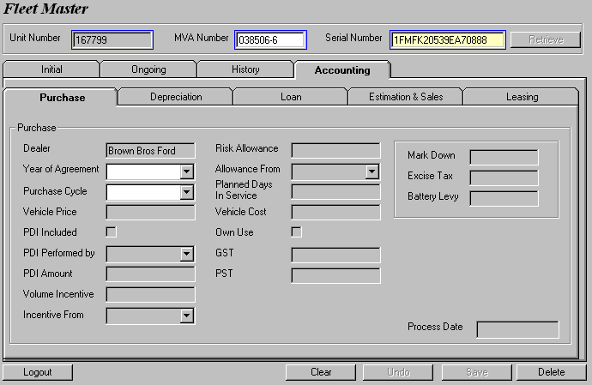
Figure 16: The purchase screen allows only these two fields for selection because the remaining fields are normally pre-set in the FA_Purchase_Agreement form.

Recall that we have already pre-set the purchase data for the EXPEDITION LTD MAX-2009 model in FA_Purchase_Agreement. Therefore, once you select a value for both Year of Agreement and Purchase Cycle, the Vehicle Price, PDI Included, PDI Performed by, PDI Amount, Volume Incentive, Incentive From, Risk Allowance, Allowance From, Planned Days In Service, Mark Down, Excise Tax and Tire & Battery Levy fields will be populated automatically. You are welcome to change any of the populated values. Save your purchase data and the Process Date field is updated with the current date.
NOTE
If there are no pre-set data in the maintenance table, then selecting a value for both Year of Agreement and Purchase Cycle will only enable the remaining twelve fields for data entry.

NOTE
On all the Fleet Master’s Accounting screens, you must ensure that all required fields (i.e. the yellow fields) are not left empty upon saving. If any of the required fields is empty, a warning message will show up and you may choose to clear all data in the screen, or simply populate the empty required field with a value.

3.2 Depreciation

This screen is used to record when depreciation start and end as well as the depreciation amount or rate (GIS supports both flat and percentage depreciation rates). You can also check the vehicle’s current book value for reference. GIS supports multiple depreciations throughout the vehicle’s life cycle.

Click on the Start New Depreciation button to start. Since we have already pre-set the purchase agreement information for your vehicle model, clicking on the button will automatically populate the Depreciation Amount field. The Depreciation Start Date field will be populated automatically if your vehicle has a non-empty GIS ISD. Remember GIS ISD? We mentioned that it’s the date your vehicle officially goes into service in Section 1.3 Rental/ Lease Use. Click Save and your data entries are recorded in Depreciation History. The Start New Depreciation button will become available again when you end the current depreciation.

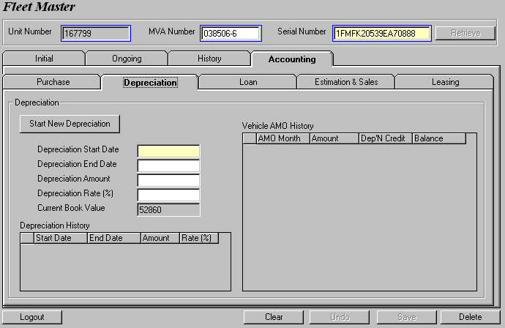
Figure 17: Initial Depreciation screen before you start new depreciation shows the current book value.

Notice that the initial Current Book Value before you start depreciation is the vehicle cost (See Figure 17). This field indicates how much value your car is worth currently (i.e. at the very moment). Once you start depreciation, expect the Current Book Value to go down since your car loses its value as you use it.

TIP!
If you made a mistake by saving the wrong depreciation data, you can delete depreciation from history by entering the Depreciation Start Date in the Depreciation End Date field and click Save. You can also perform deletions the same way for loan and lease.

You can ignore Vehicle AMO History for now, we will come back to it later in the tutorial when we talk about Month End Processing.

2.3 Loan

This screen records all loan information of a vehicle such as the financial institution, principal rate (GIS supports both flat and percentage principal rates) and etc. GIS allows multiple loans throughout the vehicle’s life cycle and supports any cut off date for interest calculation. Please note that GIS can support interest-only loan (Line of Credit).

Before you start recording loan data, recall that you should make good use of the maintenance modules first. There are three maintenance modules related to the Vehicle Loan – FA_Financial_Institution (Figure 18), FA_Loan_Interest_Rate (Figure 19) and FA_Loan_Principal_Rate (Figure 20). Record the loan information in these forms with reference to the general loan agreement with your financial institution.

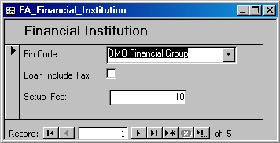
Figure 18: Add a financial institution and its attributes.

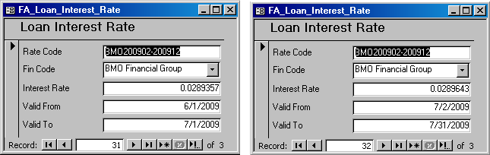
Figure 19: Defining interest rate codes for a financial institution along with their rates and valid dates.

Different principal rates can be defined depending on when the loan is paid. Figure 16 shows a 2-year loan with a rate of 2.25% for the first 23 months and 48.25% for the last month.

Note that you have to perform your own calculations for the split rates. The loan principle rate module only allows for the recording of data so you are responsible for ensuring that your calculations are correct.
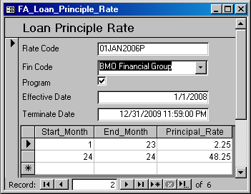
Figure 20: Setting up principal rate codes for each financial institution.

Now that you have updated the maintenance modules, go back to Fleet Master to record your vehicle’s loan information. First, populate the Financial Institution and Finance Start Date fields. These two fields will filter out unrelated rates from the Principal Rate Code drop down list. Then, fill out the rest of the form. After you save your data entries, a record will be displayed in Loan History (See Figure 21).

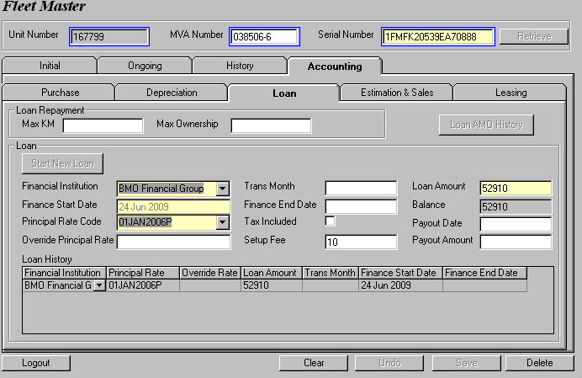
Figure 21: A record is added to Loan History after you save your changes in the Loan screen.

We know that we have to pay out our loan within the agreed term of loan, which is 2 years for BMO. Each month when you amortize the loan, GIS calculates the principal and interest payments we need to make automatically by fetching the rates and effective duration of the rates recorded in FA_Loan_Principal_Rate and FA_Loan_Interest_Rate.

Let’s look at FA_Loan_Principal_Rate again (Refer to Figure 20).

Notice that the principal rate of the ending month of the loan period is different from the previous months. This is because the last payment completely pays off the remainder of the loan. You should also expect the balance to be zero at the end of the loan period.

You can always start a new loan after your current loan has ended.

What if you originally have a 2-year loan and for some reason, you get to extend the loan? You would need a new principal rate code, wouldn’t you? The problem is you know that you cannot change the rate code without ending the current loan first, and you absolutely do not want to end your current loan because you are about to extend it.

There is a simple little trick. Add a new rate code in the maintenance modules pertaining to the loan extension. Delete your loan by entering the Finance Start Date into the Finance End Date field and save your loan data. Notice that your loan is now removed from Loan History and you are free to switch to another rate code. That way, your original loan amount stays the same, your starting date stays the same and your loan gets an extension.

3.4 Lease

This screen is used to record all information pertaining to the leasing of a vehicle. Sometimes, Budget lease its cars to third parties instead of renting them out. If the car is used as a lease car without being used as a rental car at all, then depreciation for this car starts on the day the vehicle’s status is set to ‘Lease’. In other words, this lease car goes into service when we set its status to ‘Lease’.

Let’s say you decide to lease your car to Phelps Leasing Ltd. Before you enter any lease data, you should record the lessee’s information in the FA_Lessee form (See Figure 22).
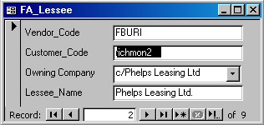
Now, you can proceed to record your lease data in Fleet Master’s Lease screen. The Initial Cost field is usually the current value of the vehicle. Populate the rest of the fields and save your changes (See Figure 23). Note that you can always start a new lease after your current lease has ended.
Figure 22: Creating a lessee in the lessee module.

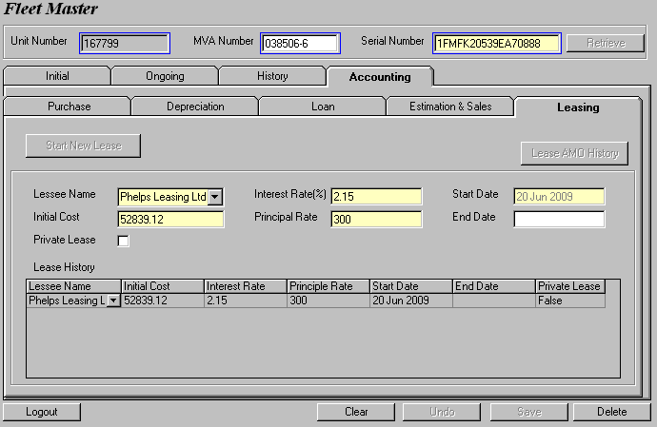
Figure 23: A record is added to Lease History after you save your changes in the Lease screen.

NOTE
Check the Private Lease flag if your vehicle is leased to family members of Budget’s owner.

3.5 Estimation & Sales

When it’s time to turn back or sell a vehicle, the vehicle will be moved to a non-rental location. Next we have to estimate the selling price of the vehicle. Go to Fleet Master’s Estimation & Sales screen and click on the Start Estimation button. This action will enable the screen and populate the fields. If you have not changed the status of the vehicle to ‘Signed Off’ or ‘Pulled for Disposal’, the Out of Service Date field will be left empty. You can always manually enter or change this date. Save your estimation data once you have populated the mandatory fields. The estimation screen allows you to change your estimation data to check for different estimated selling prices even after you saved.

Notice that the Sales screen is grayed out entirely. Selling a car has two pre-requisites. The first is to have an estimated selling price for your car. You have already done that by saving your estimation data. The next one is to change the status of your vehicle. The status you can change to depends on the vehicle’s order (See table below). Recall that changing vehicle status takes place in the Status Update screen.

Vehicle Order | Action | Change Status to
Program Vehicle | Turn back to manufacturer | Signed Off
Program Vehicle | Sell to third party | Sold
Risk Vehicle | Sell | Sold

Before you can change your car’s status to either ‘Signed Off’ or ‘Sold’, you have to remove the licence plate from your car. To do that, go to the Vehicle Licence Inventory screen. Yes, this is the same screen you used previously to assign #167799 a licence plate number. Enter the removal date and time, then click Save (See Figure 24).

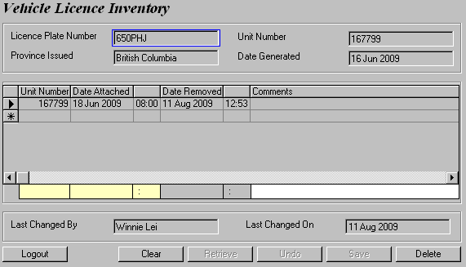
Figure 24: The license plate attachment and removal history are stored in Vehicle License Inventory.

Now go to the Status Update screen and update your car’s status. We want to return unit #167799 back to the manufacturer under a turn back agreement. So let’s change its status to ‘Signed Off’.

Return to the Estimation & Sales screen now and you will see that the Sell to field in the Sales screen is now available for selection.

The manufacturer for unit #167799 is Ford. Therefore, sell the car to Ford Canada. Immediately you will see that the Sales screen is enabled for data entry. It is also almost impossible to notice the colorful changes on the Estimation screen. Its Manufacturer’s Cost, Price Protection, Deduction, KM Reading, KM Charge, In-Service Date and Out of Service Date fields now wear shades of orange (See Figure 25) in an attempt to alert you that these fields require your careful attention. This is because once you record and save your sales data, you cannot undo your save and modify your data if a mistake occurs. Therefore, take the time to verify the fields in orange.

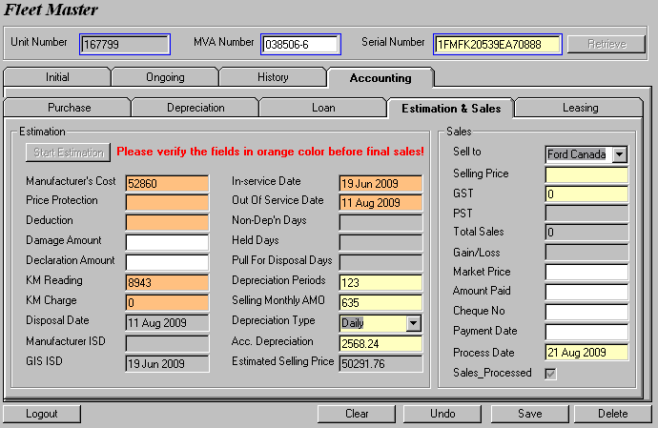
Figure 25: The orange fields require your verification before you move on to record your sales data.

Once you are done, you can proceed to pricing your car with reference to GIS’ Estimated Selling Price and the Market Price. Save your changes and the entire Estimation & Sales screen will gray out.

4 Month End Processing

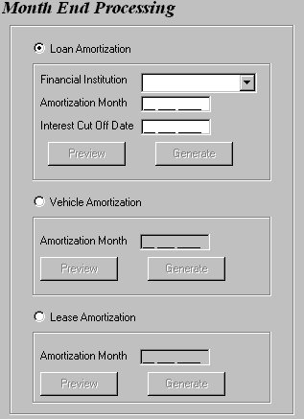
Figure 26: The Month End Processing screen.

Loan Amortization
Some vehicles in Budget are financed under a loan. In such cases, we need to make monthly payments that consist of a portion of principal and a portion of interest to our lender. GIS comes with a powerful month end processing tool that allows you to generate monthly amortization schedules using the information you recorded in Fleet Master’s loan screen.
Let’s go back to unit #167799. First, select Accounting from the Fleet Control menu, then select Month End Processing. The Month End Processing screen contains three options for generating different amortization schedules (See Figure 26). Click on the Loan Amortization option and you will see that its three fields become enabled. Recall that our lender is BMO. So select ‘BMO Financial Group’ from the Financial Institution drop down list.
You may wonder why the field is labeled ‘Amortization Month’ when it accepts a date entry. In fact, the day parameter of the Amortization Month field does not matter. GIS only takes into account the month and year parameters of the date you enter. Recall that we financed the loan for your car on June 24, 2009. So go ahead and enter any date in June 2009.

The Interest Cut Off Date field differs depending on the financial institution we loan from. In the case of BMO, the interest cut off date falls on the last day of the month. So, you have to enter 30 Jun 2009 here.

NOTE
The Interest Cut Off Date you enter must always be within the same month as your Amortization Month.

Now, click on the Preview button.

A Loan Monthly Amortization Report, as shown in Figure 27 opens. This report contains the amortization data of all cars and trucks for June 2009. The entry of your car is highlighted in red:

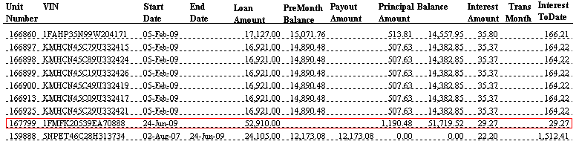
Figure 27: A page from the Loan Monthly Amortization Report.

From this amortization schedule, we know that the principal amount and interest you have to pay BMO for the month of June totals up to $1190.48 + $29.27 = $1219.75.

Now, let’s try the Generate button.

NOTE
Once the (loan, vehicle and lease) amortization schedule is generated for a particular month, it cannot be generated for the same month again. Therefore, you should always preview the amortization data first and generate it when you are absolutely sure everything is correct.

Other than the Generate button turning gray, it seems that nothing else had happened. Not quite. Go to Fleet Master and retrieve your vehicle. Switch to the Loan tab. Notice that the Loan AMO History button is now clickable and the Balance has changed. Click on it and you will see a new entry in the Loan AMO History window that pops up (See Figure 28). GIS has magically created a monthly amortization schedule for your vehicle within seconds!

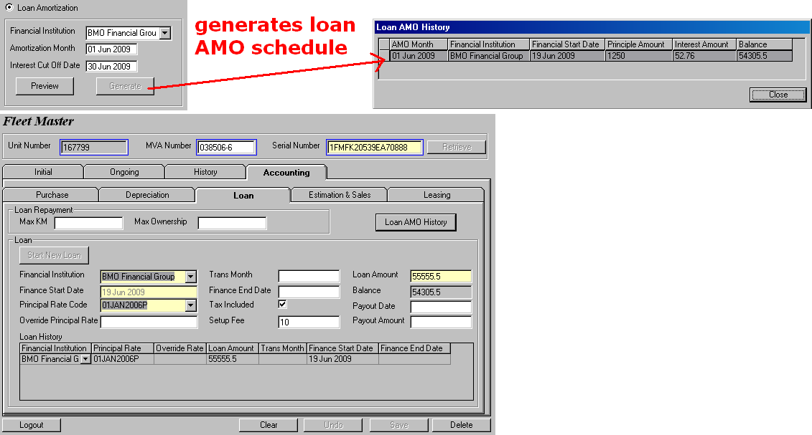
Figure 28: Clicking the Generate button creates a loan amortization schedule for all vehicles on loan with the specified financial institution for the specified month.

You can also view the generated Loan Monthly Amortization reports in the On-Request screen from the Reports menu. These generated reports are exactly like the reports when you preview them. You can only see data on the reports after clicking on the Generate button.

Vehicle Amortization
We want to keep track of how much our vehicles depreciate (i.e. loses its value) each month and how much it is worth at the moment. So, let’s use unit #167799 again. Recall that your vehicle was officially in service on June 19, 2009. So why don’t we find out how much your vehicle has depreciated in June?

Recall that GIS only takes into account the month and year parameters in the Amortization Month field. So go ahead and enter any date in June 2009. Let’s click on the Preview button first.

A Fleet Monthly Amortization Report, as shown in Figure 29 opens. This report contains the amortization data of all cars and trucks for June 2009. The entry of your car is highlighted in red:

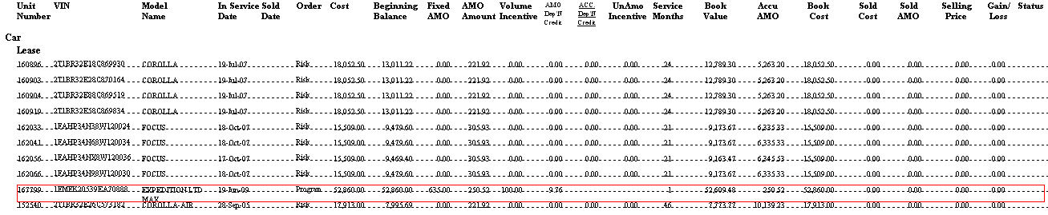
Figure 29: A page from the Fleet Monthly Amortization Report.

From this amortization schedule, we know that the value of your car has reduced by $250.52 and it is currently worth $52659.48.

Now, let’s try the Generate button. The Generate button is disabled again, like our previous Loan Amortization example. Go to Fleet Master and retrieve your vehicle. Notice that there is now a new entry in Vehicle AMO History in the Depreciation screen (See Figure 30).

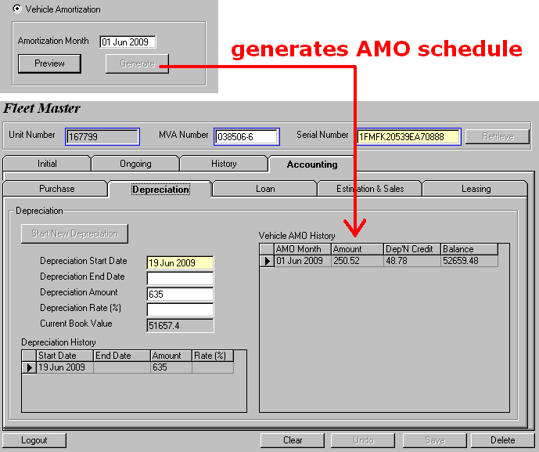
Figure 30: Clicking the Generate button creates a vehicle amortization schedule for all vehicles in service for the specified month.

You can also view the Fleet Monthly Amortization Report via Reports/On-Request. If you open this report, you may notice that there are a few columns pertaining to depreciation credits missing. They can be found in the Volume Incentive Report (See Figure 31) in the same On-Request screen. The entry of your car is highlighted in red:

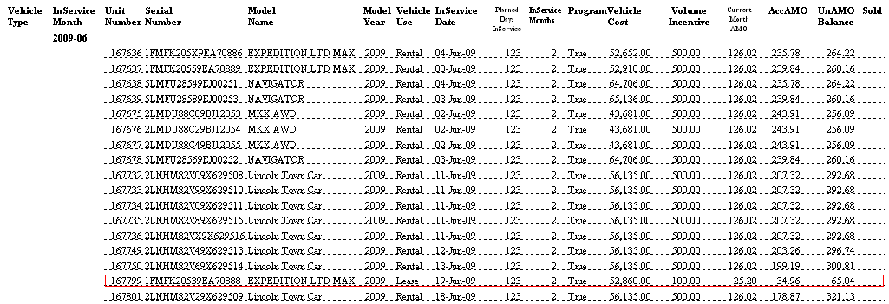
Figure 31: A page from the Volume Incentive Report.

Lease Amortization
Budget maintain contracts with its clients to lease its cars in exchange for an initial down payment as well as monthly principal and interest payments from the start until the end of the lease. We want to keep track of how much principal and interest payments we should collect from our lessees every month over their term of lease.

The steps to generate lease amortization data are the same as Vehicle Amortization, so we will leave you to explore this on your own.

5 Export data to ACCPAC

The Fleet Accounting Export tool is a new GIS tool for generating account payable, account receivable and general ledger entries from data entries in the Purchase and Estimation & Sales modules. These accounting entries can then be exported as Microsoft Excel files, only to be imported later into Budget’s central accounting system – ACCPAC.

Launch the tool from the Fleet Control/Accounting menu. You can generate accounting entries for purchase or sales or both transactions at any given RBR Date Range. This RBR date is the date when the transaction is processed. In our example, we will focus on generating purchase transactions. Click on the Run Batch button after specifying 6-Jul-2009 to 7-Jul-2009 as the date range. GIS will then generate data into the FA_AP_Header, FA_AP_Detail, FA_AR_Header, FA_AR_Detail and FA_Sales_Journal tables. The invoice/document number will be created based on unit number. Note that the four tables mentioned above are stored in an internal database and are not viewable. We include them in this tutorial to give you a better understanding of the process of accounting entry generation to export (See Figure 32).

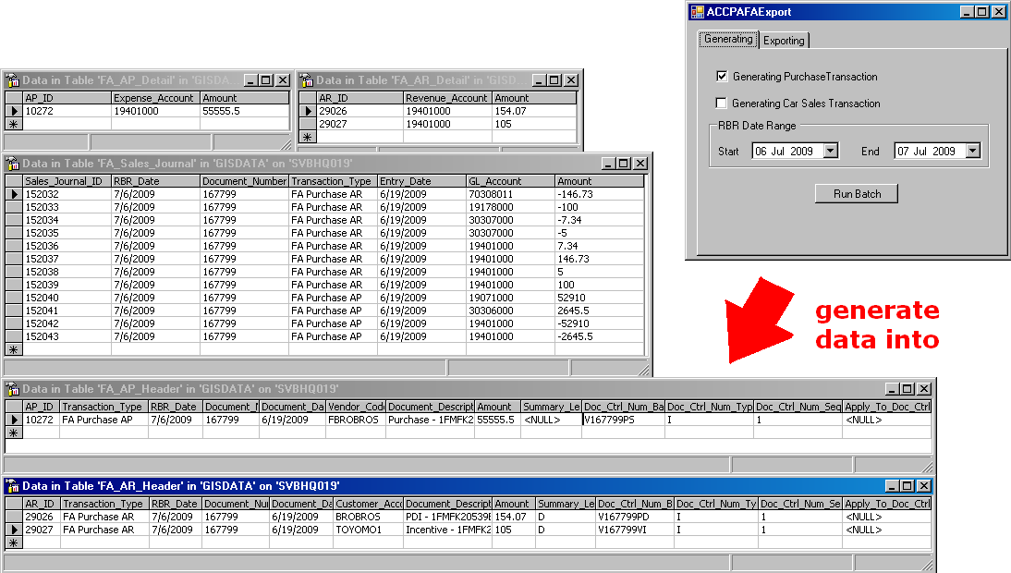
Figure 32: The entries for the specified purchase transactions are generated and stored in four tables.

Once the data for the purchase transaction are generated, switch to the Exporting tab and export them as Excel files into the directory you specify in the Output File Path field. A new folder will be created and named by the RBR Date Range (See Figure 33). Note that the files ending with ‘adj’ are always empty because the adjustment function is not implemented in GIS yet.
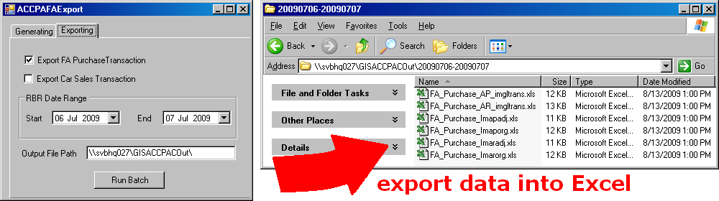
Figure 33: The purchase entries stored in the four tables mentioned above are exported into Excel.

Now that you have all your Excel files ready, you can finally open ACCPAC to process the A/P, A/R and G/L invoices. In the ACCPAC authentication window, select ‘svbhq007 - Budget Rent a Car of BC Ltd’ from the Company drop down list and login with your designated user ID and password. On ACCPAC’s left panel, select A/P Transactions to open the Accounts Payable menu to the right. Click on Invoice Batch List and start a new batch. An A/P Invoice Entry window will open, as shown in Figure 34.

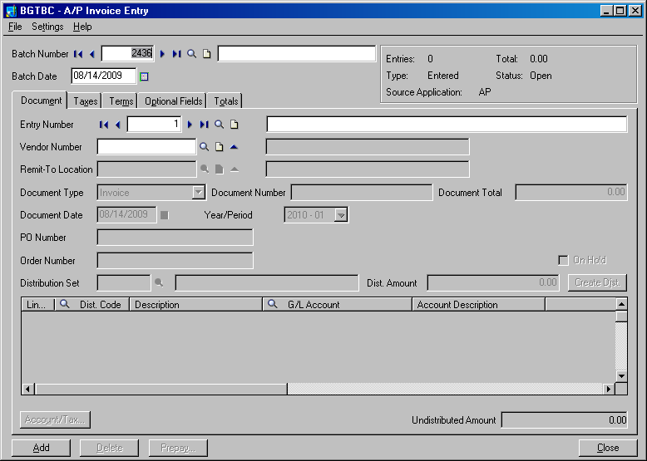
Figure 34: Creating an A/P invoice entry in ACCPAC.

It’s a good habit to write a description for every invoice you create. The description box is seen next to the Batch Number field. On the top menu, click File/Import. Browse for the directory you specified in your Output File Path. Recall that the folder containing all the accounting files that was generated by the Fleet Accounting Export tool is named by the RBR Date Range. Therefore, search for the directory (i.e. \\svbhq027\GISACCPACOut\20090706-20090707 and select the file containing A/P entries (i.e. FA_Purchase_Imaporg.xls) to import. Once the file is imported successfully, its records are then inserted into the invoice, as shown in Figure 35.

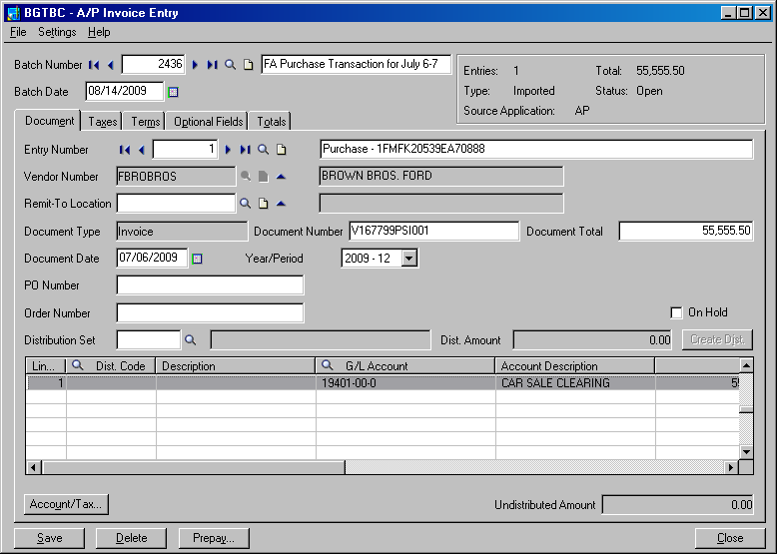
Figure 35: The entries in the imported FA_Purchase_Imaporg.xls are loaded into ACCPAC.

You can also print preview the invoice to check the correctness of the data, as shown in Figure 36.

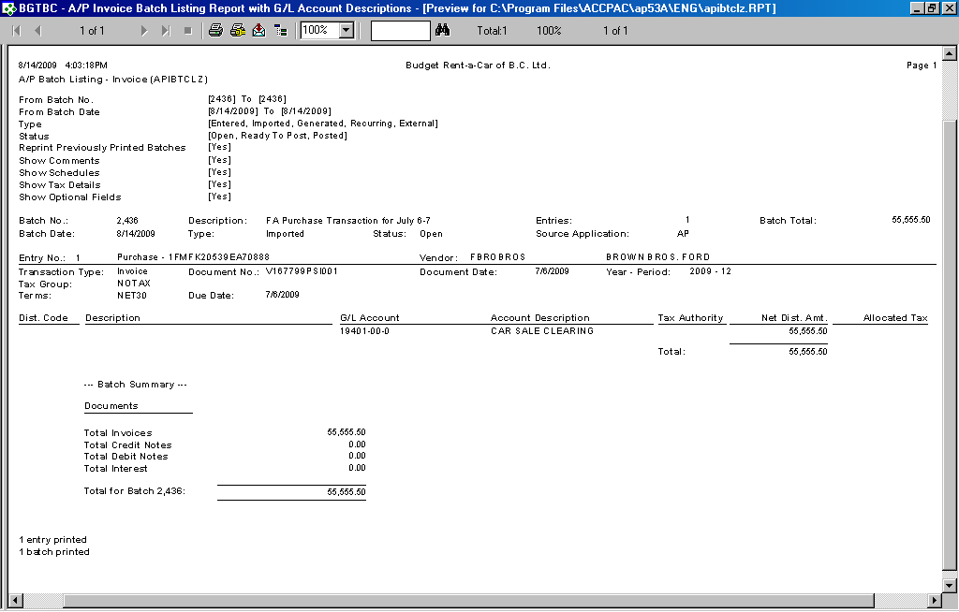
Figure 36: Invoice of the purchase transaction.
Repeat the same procedure for A/R and import FA_Purchase_Imarorg.xls. The last step is to import the G/L files. On ACCPAC’s left panel, select G/L Transactions to open the General Ledger menu to the right. Click on Batch List and start a new batch. A G/L Journal Entry window will open and you can import FA_Purchase_AP_imgltrans.xls and FA_Purchase_AR_imgltrans.xls into the window.
The procedures for generating sales transactions are very much the same as generating purchase transactions. The main difference lies in the Excel files whose naming convention is changed from Purchase to Sales - FA_Sales_Imarorg.xls, FA_Sales_Imaradj.xls and FA_Sales_AR_imgltrans.xls. Import the A/R and G/L files into ACCPAC and you’re done!

NOTE
If you get an error message like the screen below while attempting to import any of the Excel files into ACCPAC, you may need to delete all opened invoices that contain accounting entries of the same date as the Excel file you want to import.

6 Reports

6.1 Fleet Operation Reports

New Vehicle Reports
This report lists all newly added vehicles (Program or Risk) within the specified time frame. Budget report the vehicle’s in-service date as the ownership date to the manufacturer so that the latter can calculate depreciation based on this date upon the return of the vehicle (buy back).

Turn Back Lease Reports
This report is run daily by the fleet personnel to get a quick overview of Budget’s fleet, especially on the current status of each vehicle and its current location.

Foreign Vehicle Control
The purpose of this report is to track foreign cars at all Budget locations based on the current date and time of query. Information such as each foreign vehicle’s unit number, model and status are recorded. If the vehicle is currently on rent, the report displays additional information about its rental such as the rental due date and contract number. When the report is run, it will show statistics of the current date and time.

Missing Kilometers
The purpose of this report is to track missing kilometers between rentals for the specified time range. Every time a vehicle is checked out or checked in, or starts or completes a movement, the mileage of the vehicle is recorded. The mileage is also recorded when a vehicle serviced. Typically, the kilometers recorded at consecutive times between rentals should be roughly the same. A large difference between these two mileages must be accounted for and is displayed on this report.

Fleet Turn Back Schedule Summary – Daily
Most rental vehicles at Budget are purchased from different manufacturers and are required to be turned back after a certain amount of time. The length of the ownership is determined by the agreements between Budget and the different dealerships involved. The purpose of this report is to determine when cars are scheduled to be returned to their respective manufacturers. The daily summary shows the amount of cars scheduled to be returned for each day of a specified month. This report is only run for Budget's program vehicles and contains details. This is a detailed report based on duration of ownership and actual km usage. This report is run for the specified time range.

Fleet Turn Back Schedule Summary – Monthly
The only difference between this report and the Fleet Turn Back Schedule Summary – Daily report is the query parameters used to generate the report. This report gives an estimation of turnbacks based on duration of ownership only (i.e. kilometers are not considered). This report is run for the specified time range.

Vehicle Utilization – Current
This report shows the number of cars that can be rented and the number of cars that are rented on a particular day. The purpose of this report is to keep track of the utilization of the fleet inventory. It only shows BRAC vehicles. When the report is run, it will show statistics of the current date and time.

Units Available for Rent
The purpose of this report is to track all vehicles that are available (all Budget vehicles and all foreign vehicles currently in the Budget system) and to view detailed information for those vehicles. This report gives a listing of all available vehicles for each location and also displays the vehicles’ physical details as well as its previous contract information. When the report is run, it will show statistics of the current date and time.

Fleet Mix
The purpose of this report is to provide an overall view of vehicles that are on rent or available for rent of the current date and time. This report breaks down all vehicle classes by showing how many vehicles are on rent or are available for rent, aiding the strategic decision making process of the company. This report includes only vehicles that are owned by Budget.

Fleet Mix Monthly
This report behaves the same as the Fleet Mix report but instead it shows the statistics of the specified month.

Vehicle Control
This report is used as an inventory listing for the rental and non-rental locations and the fleet department to audit the vehicles available at the rental location. This report will list all vehicles (car/truck) belonging to Budget that are available for rent or on contract on the current date and time.

Vehicle Due Back By Hourly
This report will display all the vehicles that are due back from contracts on each hour for the specified day. This will allow the user to know in advance how many vehicles are due back, arrange for breaks for the location staff throughout the day, check whether there are sufficient vehicle classes to meet reservations, arrange ahead of time to move vehicles in or out, and determine rate strategies to increase or decrease the rate for reservations and walkups. When the report is run, it will show statistics of the current date and time.
Vehicle Incident Summary
This report lists all details associated with a particular vehicle support incident. The report will be used to print the details for a specific vehicle incident, possibly for audit or training purposes, although it is usually used to communicate the incident information for foreign vehicles to their owning company for invoicing purposes.

Daily Operation Plan
This is a real time report used by DOP on a daily basis for planning vehicle movements for the current day.

Vehicle Sold Report
This report provides a list of vehicles which were sold during the specified dates.

Vehicle In Service Date Report
This report is used to record all dates in which the vehicles are in service. This report is typically used during month end to determine the vehicles’ in-service days for the calculation of depreciation.

Vehicle Movement Report
This report is to provide information regarding Vehicle Movement between different companies.

6.2 Fleet Accounting Reports

Monthly Amortization Report
This Fleet book contains information about vehicles’ depreciation, book value and sales information for accounting reconciliation purposes. When the vehicle is turned back or sold, Sold Cost takes the original value of Book Cost, Sold AMO takes the original value of Accu AMO and all four of AMO amount, Book Cost, Accu AMO, and Book Value will become zero in the report. When the report is run, it will show statistics of the specified month.

Loan Amortization Report
This report is a schedule that contains information about the loan’s start and end dates, the loan amount, principal and interest amounts etc. When the Finance End Date of a loan is earlier than the specified Interest Cut Off Date, Principal Amount is shown as zero in the report. On the other hand, if the Finance End Date of a loan is equal to or later than the Interest Cut Off Date, Principal Amount will be displayed in the report. After the loan is paid out, the Payout Amount is displayed and Balance becomes zero in the report. When the report is run, it will show statistics of the specified month.

Lease Amortization Report
The Loan Amortization Book is a schedule that displays information like Budget’s lessees, lease Start and End Dates, monthly principal and interest amounts. When the report is run, it will show statistics of the specified month.

Key Tag Report
This report retrieves information like licence plate number, vehicle model and color according to the specified vehicle unit number(s) and inserts them into a key tag template. This key tag will be attached to the key of the vehicle when it is being rented out or used.

Car Sales Summary Report (for Buyer)
After selling vehicles on GIS, Budget will give their buyers a summary report of the vehicles they bought during the specified date range.

Car Sales Summary Report (for Seller)
After Budget sell their vehicles on GIS, Budget will print this report to keep track of the vehicles it sold within the specified date range.

Vehicle Purchase Agreement
After selling vehicles on GIS, Budget send this bill of sales to the respective buyers.

Vehicle Release Form
After Budget sell its vehicles, they prints these forms out and sends them to the Operations department so that the Operations staff can start moving the sold vehicles within the specified transaction date range.

Loan Payout Report
This report is for Budget’s reference and contains a collection of vehicles whose loan contains a payout date and the total payout amount that was made to the financial institution.

BMO Loan Payout Report (for Bank)
Based on BMO’s template, this report contains a collection of vehicles whose BMO loan contains a payout date and the total payout amount that was made to BMO within the specified transaction date range.

Car Sales Analysis
This report consists of depreciation data, selling price, gain/loss and important details pertaining to all car sales made in the specified transaction date range.

Car Sales Estimation
This report shows the estimated selling price and factors determining that estimation for vehicles which are no longer being rented.

Volume Incentive Report
This report is a complement to the Monthly Amortization Report that focuses solely on the depreciation of Volume Incentive.

